**Question 1**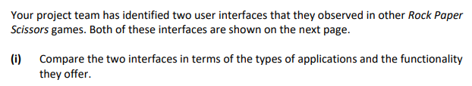

|  |
| --- |
|  |
|  |
|  |
|  |
|  |
|  |
|  |
|  |
|  |
|  |
|  |
|  |
|  |
|  |
|  |

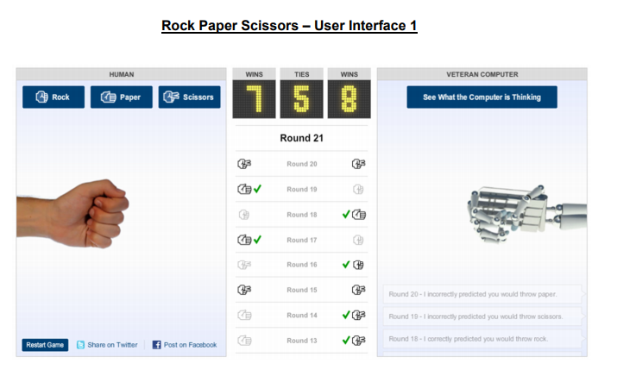

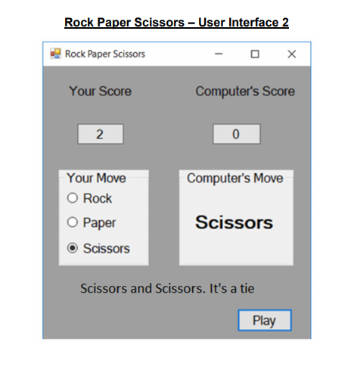



| **1.** |
| --- |
|  |
|  |
|  |
|  |
| **2.** |
|  |
|  |
|  |
|  |

**Question 2**

Go to the website for Acorn Age friendly tablet (<https://myacorn.ie/>). Using the information that you find, assess the device and its user interface using the principles of universal design.